Week 2

System Planning and Environment Design

Objective:

Planning the system environment, defining the virtual infrastructure, and setting up networking and resource allocation before deployment were the goals of this phase.

- Design of Virtual Environments

The virtual machines for Ubuntu Server and Ubuntu Workstation were hosted on the virtualisation platform VirtualBox.

This configuration enables performance analysis, security implementation, and isolated testing of server configuration.

Virtual Machines Planned:

 | Virtual Machine | OS Version | Purpose
 | Ubuntu Server | 24.04 LTS | Hosting services and security testing
 | Ubuntu Workstation | 24.04 LTS | Remote administration and monitoring
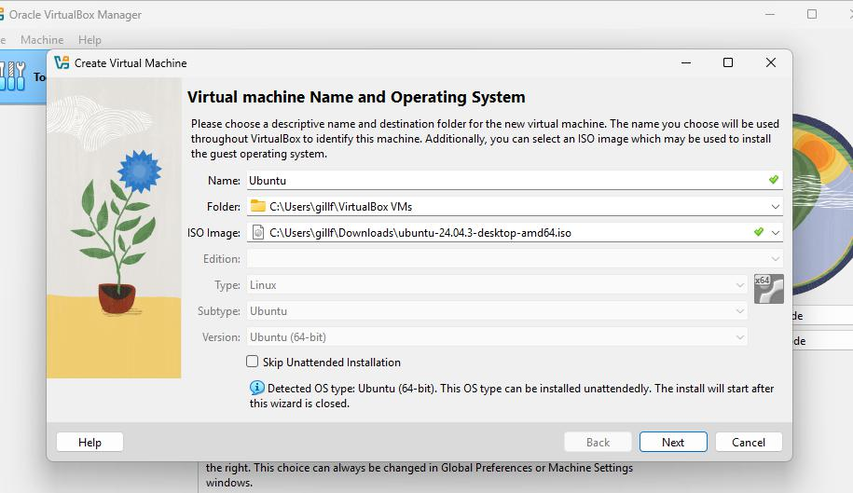

Fabian Gill A00017906

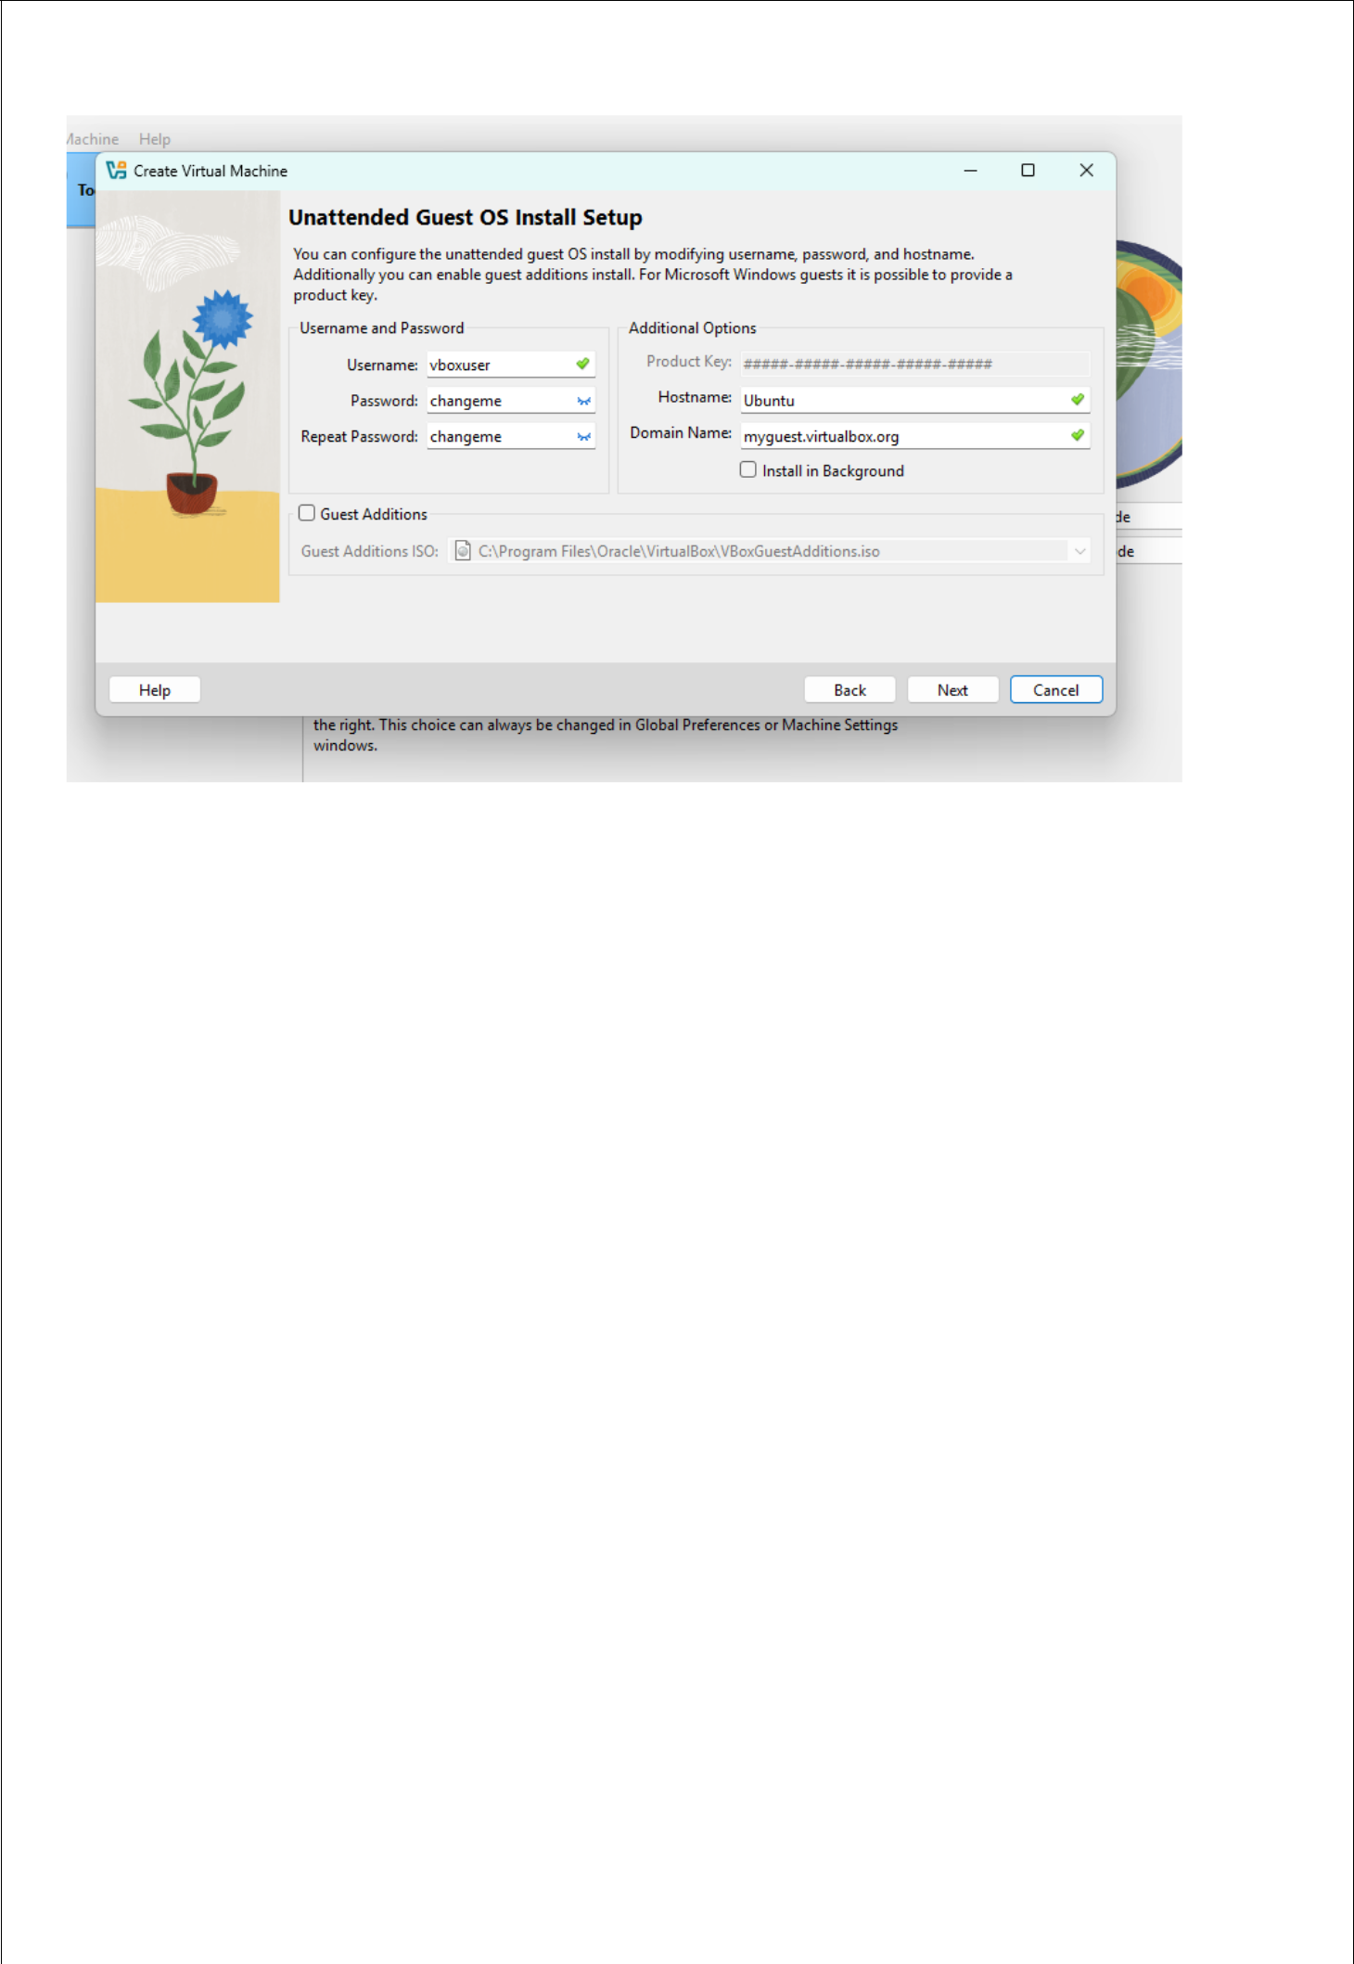

Resource Allocation Planning:

Resources | Ubuntu Server | Ubuntu Workstation
CPU | 2 cores | 2 cores
RAM | 2GB | 2-4GB
Storage | 20-30GB | 30GB
Network | NAT | NAT
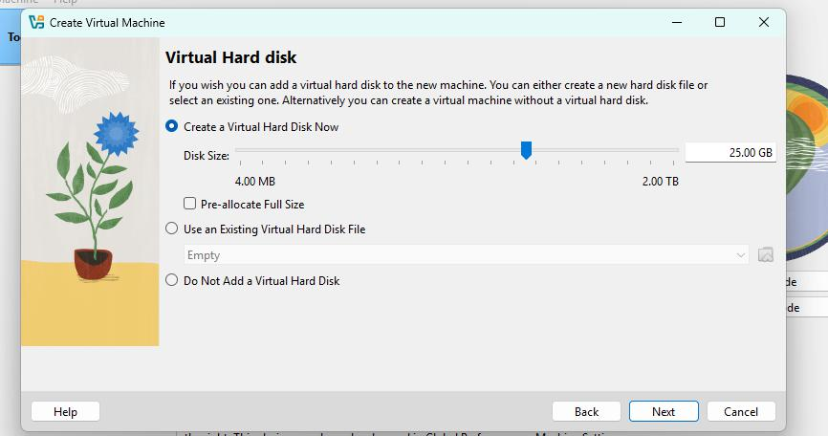

Fabian Gill | A00017906

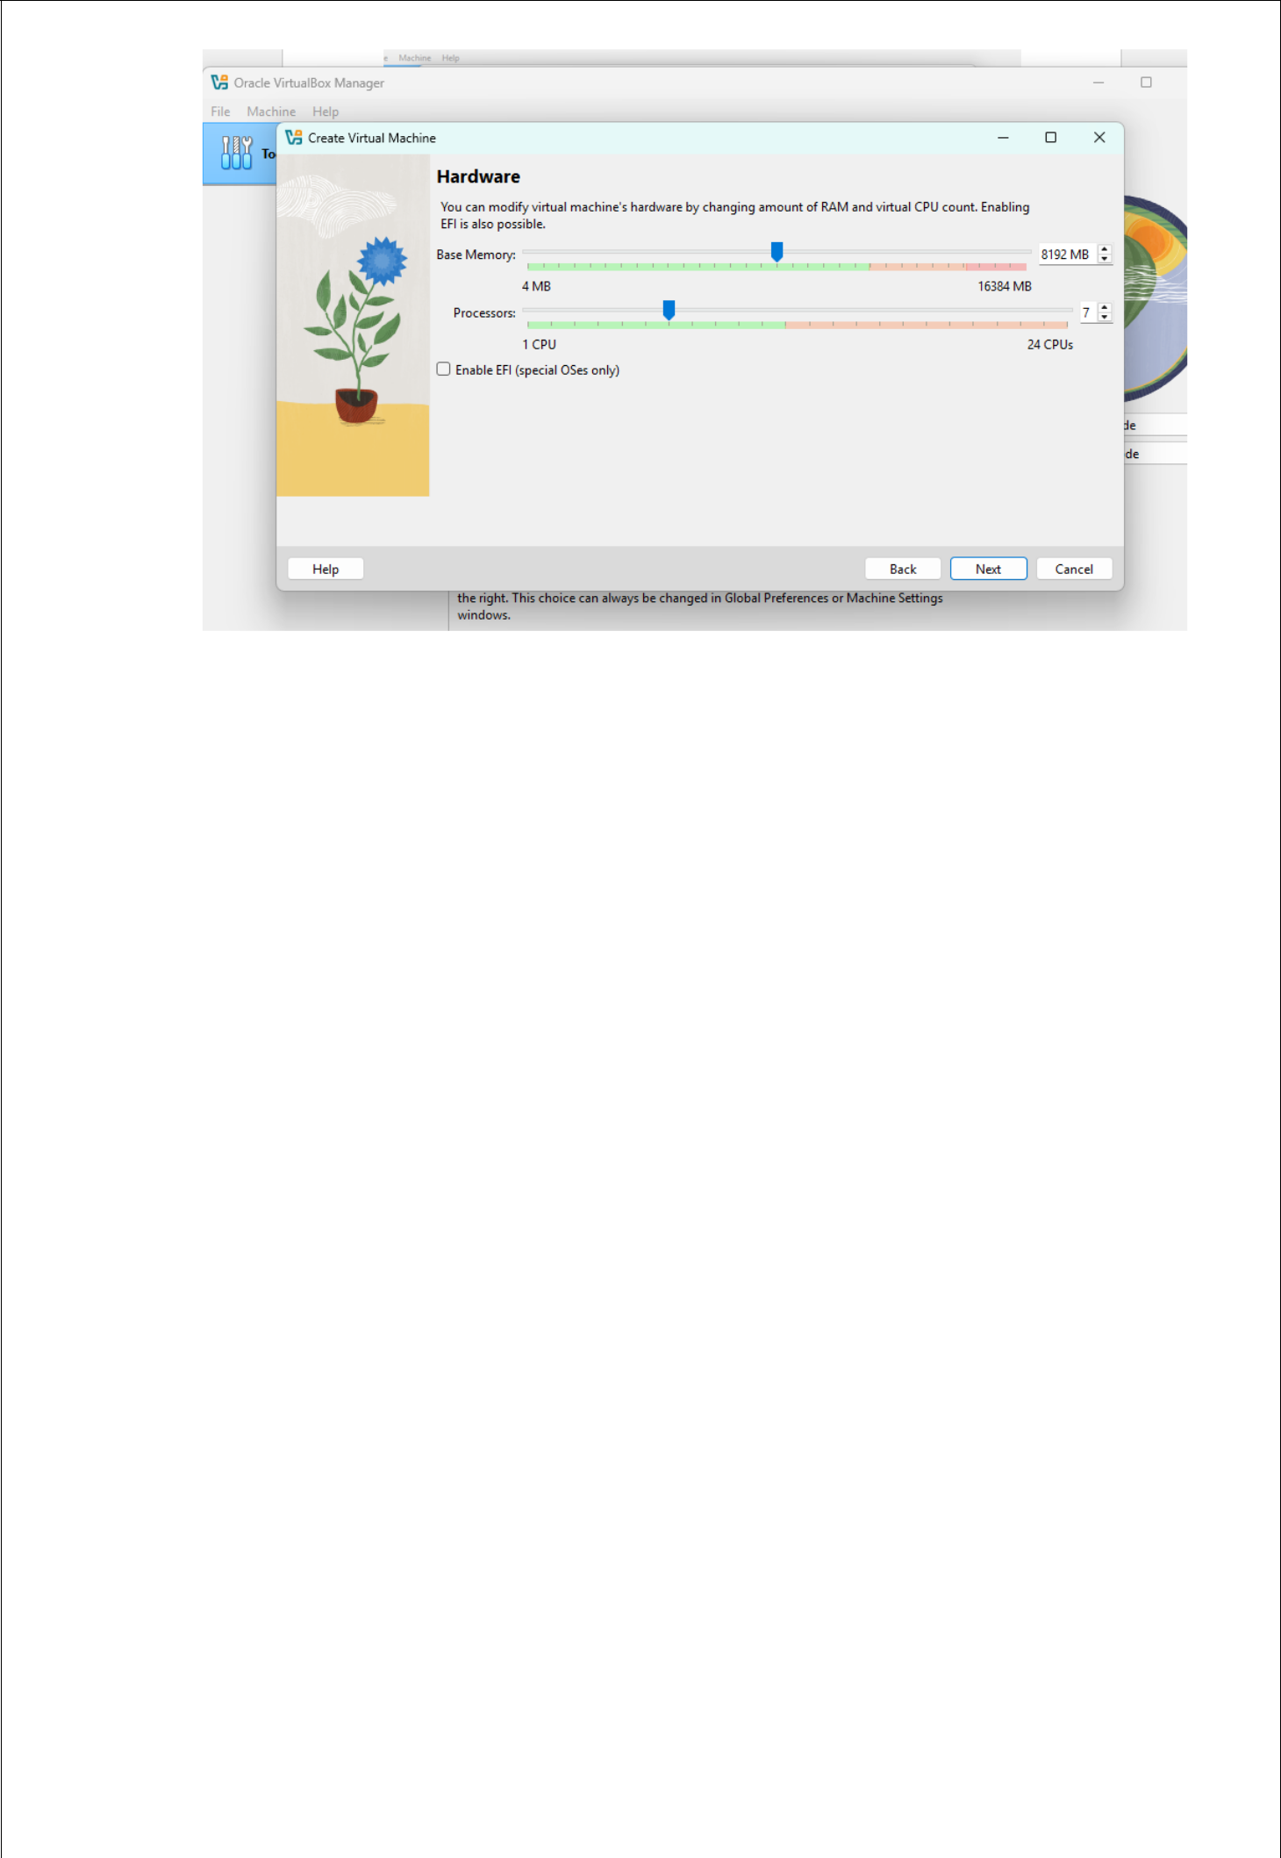

Network Configuration:

NAT networking was set up in both virtual machines to enable internet access while keeping them isolated from the host network.

Goals for the planned network:
For package updates, enable internet access.
Permit the workstation and server to communicate via SSH
Keep the lab environment safe and under control.
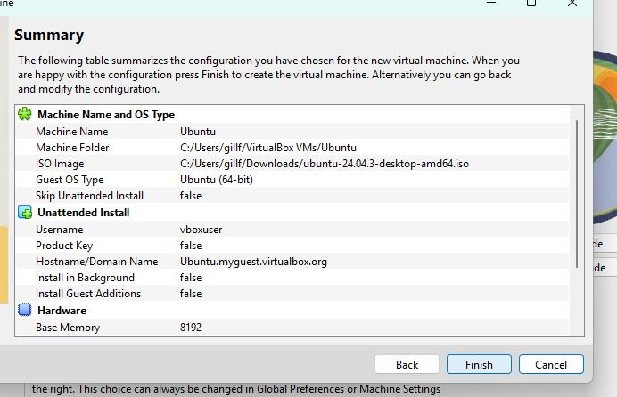

Fabian Gill | A00017906

Security Planning Consideration:

Security requirements were determined prior to system deployment in order to direct subsequent configuration stages.

Strategies for security:
SSH key-based verification
Limitations on the firewall that permit SSH from a single workstation
Administrative user who is not root
Intrusion prevention and automated updates
Later stages saw the implementation of these controls.

Tool Selection Planning:

 | Tool | Purpose
 | stress / stress-ng | CPU & RAM testing
 | fio | Disk I/O testing
 | iperf3 | Network performance testing
 | fail2ban | Intrusion prevention
 | Lynis | Security auditing

Conclusion:

Clear system design and deployment plans were established during this phase.

This planning stage served as the foundation for all configurations and security measures put in place in subsequent stages.

Fabian Gill A00017906

